Original article:
Management of maxillary flabby tissue with two part tray technique – a case report
DR. RUPAL J. SHAH, DR. SANJAY LAGDIVE, DR. NAJMUNNISHA SABUGAR, DR. DHARA KOTAK,
DR. KIRAN HADIYA
Department of Prosthodontics, GDC
Corresponding author: DR. Najmunnisha Sabugar

ABSTRACT:
Impression making in patients with flabby tissue is one of the most challenging task in complete denture prosthetics.Denture fabricated by conventional impression techniques may result in unstable and nonretentive denture and can also aggravate the existing condition, affecting the support of the denture bearing area. This case report describes one such scenario and demonstrates the use of novel impression technique that is based on osborne’s technique for management of maxillary flabby tissue.
KEYWORDS: Flabby ridges, fibrous ridges, two tray technique, positioning rod, mucostatic

INTRODUCTION:
Excessive movable tissue, a clinical condition resulting from excessive resorption of the alveolar ridge followed by fibrous tissue replacement is a common finding, particularly in the upper anterior region (24%in edentulous maxilla, 5% in edentulous mandible) of long term denture wearers^{1,2}. Typically, these tissues are composed of mucosal hyperplasia, loosely arranged fibrous connective tissue as well as more densecollagenized connective tissue³. Forces exerted during impression making can result in distortion of this mobile tissue, leading to altered denture positioning and loss of peripheral seal. Hence an impression technique which will compress the non flabby tissue to obtain optimal support and at the same time, will not displace the flabby tissue, is required. A multitude of impression techniques are suggested in the past to help record a suitable impression of flabby denture bearing area.
Liddelow in 1964⁴ has described a technique in which multiple viscosities of polyvinyl siloxane impression materials were being dispensed in the custom tray. High/Medium viscosity material was used to border mould the vestibular areas, low viscosity material was used for non flabby area and ultralow viscosity material was used for flabby areas. Osborne in 1964^{5,6}described an impression technique involving two impression trays. The aim of this technique was to maintain the contour of the easily displaceable tissue while the rest of the denture bearing area is recorded.Watson in 1970⁷had described an impression technique to record flabby tissue in maxillary anterior region.William H Filler in 1971⁸ described a technique in which 2 trays were fabricated, one with a window in flabby tissue area, with handles on molar region and the second one which was keyed on the first tray.Khan Z, Jaggers J, Shay J in 1981⁹ described a technique in which they made window opening in flabby region. After border moulding, non flabby area was recorded with zinc oxide eugenol and flabby part was recorded with impression plaster by paint on technique.
Here, an alternative method of making a definite impression for maxillary edentulous arch with displaceable tissues, using zinc oxide eugenol and impression plaster is described.
CASE REPORT:
A male patient of age 64 years reported to the Department of Prosthodontia, Government Dental College and Hospital, Ahmedabad with the chief complaint of missing teeth and difficulty in mastication. No relavant medical history was found. On intraoral examination it was noted that there was an area of flabby tissue in the maxillary anterior region extending from the canine region from one side to other and blanching of the tissue was seen when pressure was applied with the end of the mouth mirror.
Technique involves the following steps:
- The preliminary impression was made using irreversible hydrocolloid impression ( DPI IMPRINT ALGINATE ) material and primary cast was poured. Extent of the displaceable tissue was marked on the impression so that it would be transferred to the primary cast.
- A closed fitting autopolymerising tray was fabricated such that the flabby area marked on the cast was left uncovered.
- Positioning rod made from 19 gauge wrought wire for guiding second tray was attached on the first tray.
- 3 mm thick spacer was given for impression plaster over the first tray and the second tray was made over it.
- Border moulding of the palatal tray was done with the help of (DPI PINNACLE) tracing sticks and final impression was recorded with (DPI) zinc oxide eugenol impression paste.
- Spacer wax from the second tray was removed and impression plaster was loaded in the second tray and pick up impression was made.
- Master cast was prepared after beading and boxing of the final impression.
- Rest of the steps were followed for conventional denture fabrication.

DISCUSSION:
The importance of Prosthodontics as a speciality has emerged because of the constant need to replace the missing dentition and the surrounding structures. All the steps in the denture fabrication are interdependent on each other. The success of the denture mainly depends on the impression technique as it is the first and foremost step involved in the complete denture fabrication. Prosthetics is a branch which entails a lot of work in absence of the patient which necessitates the model that is the exact replication of the tissues involved in the denture bearing area.As and when new materials and methods come into practice to overcome certain problems and for the convenience of the operator and the patient; the basic objectives to provide retention, stability, support ,esthetics and preservation of the oral tissues should not be overlooked. With various techniques and concepts available in literature, it has become easy to understand and select one of these impression technique that suits our clinical condition the best.
In the technique described in this article, non flabby area was recorded with closed fitting custom tray loaded with medium viscosity impression material to obtain maximum support and peripheral seal; while flabby area was recorded with impression plaster which is the most mucostatic impression material. In this case flabby area in anterior region was present till the sulcus, so border moulding for two part impression technique was not possible in the anterior region. Hence, in this particular case two part technique was the best choice of impression technique.
Other than modifying impression technique to manage fibrous ridge, various other approaches can also be considered such as surgical exicison of the flabby tissue, use of dental implants and fabricating a liquid supported denture. Limitations of the surgical approach are that most of the patients in Prosthetics department are elderly and have complex medical conditions or are unsutaible candidates for surgery for other various reasons. Moreover, surgical removal of flabby tissue may result in shallow ridge which provide less resistance to lateral forces. Use of dental implants is also not an economical option. Fabricating a liquid supported denture is a cumbersome procedure.
CONCLUSION:
In conventional complete denture prosthodontics, variety of modified impression techniques are available to solve the problems caused by flabby tissue during denture fabrication. The following criteria can be considered to select proper impression technique:
1. Patient’s requirements
2. Extent of flabby tissue
3. Importance of optimizing other design factors
In this technique, consideration has been given to the choice of impression material as well as to the design of the impression tray to minimize the amount of pressure exerted on flabby tissue.

REFERENCES:
1. Carlsson GE, clinical morbidity and sequelae of treatment with complete sentures. J Prosthet Dent 1998;79:17-23
2. Xie Q, Nahri TO, Nevalainen JM, Wolf J, Ainamo A. Oral status and prosthetic factors relates to residual ridge resorption in elderly subjects. Int J Prosthodont 1997;55:306-13
3. Magnusson BC, Engstorm H, Kahnberg KE. Metaplastic formation of bone and chodroid in flabby region.
4. Liddelow KP. The prosthetic treatment of elderly. Br Dent J 1964;117:307-315
5. Osborne J. Two impression methods for mobile fibroud ridges. Br Dent J 1964;117:392-394
6. Delvin H. A method for recording an impression for a patient with fibrous maxillary alveolar ridge. Quint Int 1985;6:395-397
7.Watson RM. Impression technique for maxillary fibrous ridge. Br Dent J 1970;128-552
8.Filler WH. Modified impression technique for hyperplastic alveolar ridge. J Prosthet Dent 1971;25(6):609-12
9. Khan Z, Jaggers J, Shay j. Impression of unsupported movable tissues. JADA 1981;103:590-92
10. Crawford R W I, Walmsley A D. A review of prosthodontic management of fibrous ridges.Br dent J 2006;199(11):715-719
11. Sajani R., RanukumariA.Impression technique for effective management of flabby ridge- An overview. Journal of scientific dentistry 2012;2(2):29-33
12. Michael H. C. Shum, Edmond H. N. Pow. Management of excessive movable tissue:
A modified impression technique. J Prosthet Dent 2014;112(2):387-389
13. AlperComut, Mark Andrawis. Maxillary definitive impression of excessively movable tissue with a single material. J Prosthet Dent 2015;114(4):616-618
14. Frank RP. Analysis of pressures produced during maxillary edentulous impression procedures. J Prosthet Dent 1969;22:400-13.
15. Lynch C D, Allen P F.Management of the flabby ridge: using contemporary materials to solve an old problem. Br Dent J 2006;200:258-261
16. Manmohit Singh Kumar, MD AbidHussain, RU Thombare. Rehabilitation of Flabby Tissue - A Case Report. JIDA,2011;5(7):833-835
17. Academy of Denture Prosthodontics: Principles,concepts and practices in prosthodontics. J Pros Dent 1989; 61: 88-109.
18. Hobkirk J A. Complete dentures — a dental practitioner handbook. pp 44-45. Bristol: Wright, 1986.
19. Kathuria N, Prasad R, Bhide SV. Flabby alveolar ridges: a modified technique to treat
this clinical challenge. Eur J Prosthodont Rest Dent 2011;19:21-4.
20. Kathuria N, Prasad R, Bhide SV. Flabby alveolar ridges. A modified technique to treat this clinical challenge. Eur J ProsthodontRestor Dent 2011;19:21-4.

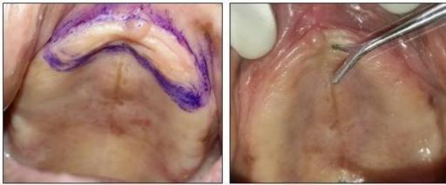

FIG.1 INTRAORAL VIEW OF MAXILLARY ARCH SHOWING EXTENT OF FLABBY TISSUE CONFIRMED BY BLANCHING ON PRESSUR

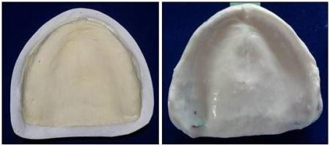

FIG. 2 PRIMARY IMPRESSION WITH ALGINATE AND PRIMARY CAST

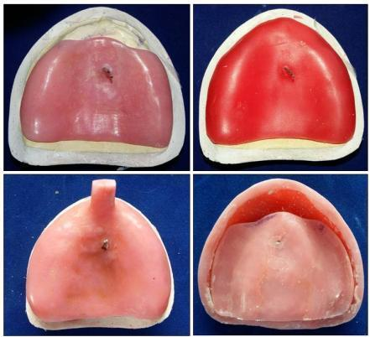

FIG. 3 PALATAL TRAY WITH POSITIONING ROD, SPACER WAX OVER FIRST TRAY AND SECOND PART OF TRAY OVER A FIRST TRAY

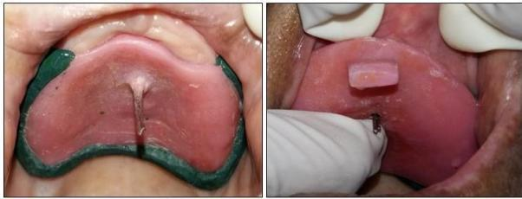
FIG.4 INTRAORAL PLACEMENT OF FIRST AND SECOND PART OF TRAY

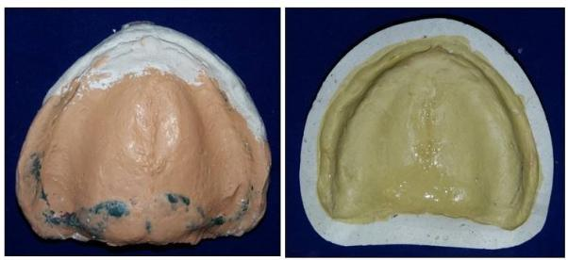

FIG.5 FINAL IMPRESSION OF UPPER ARCH AND MASTER CAST

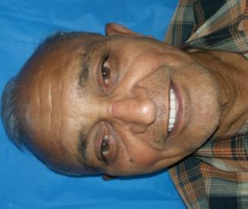

FIG.6 PATIENT WITH FINAL PROSTHESIS

